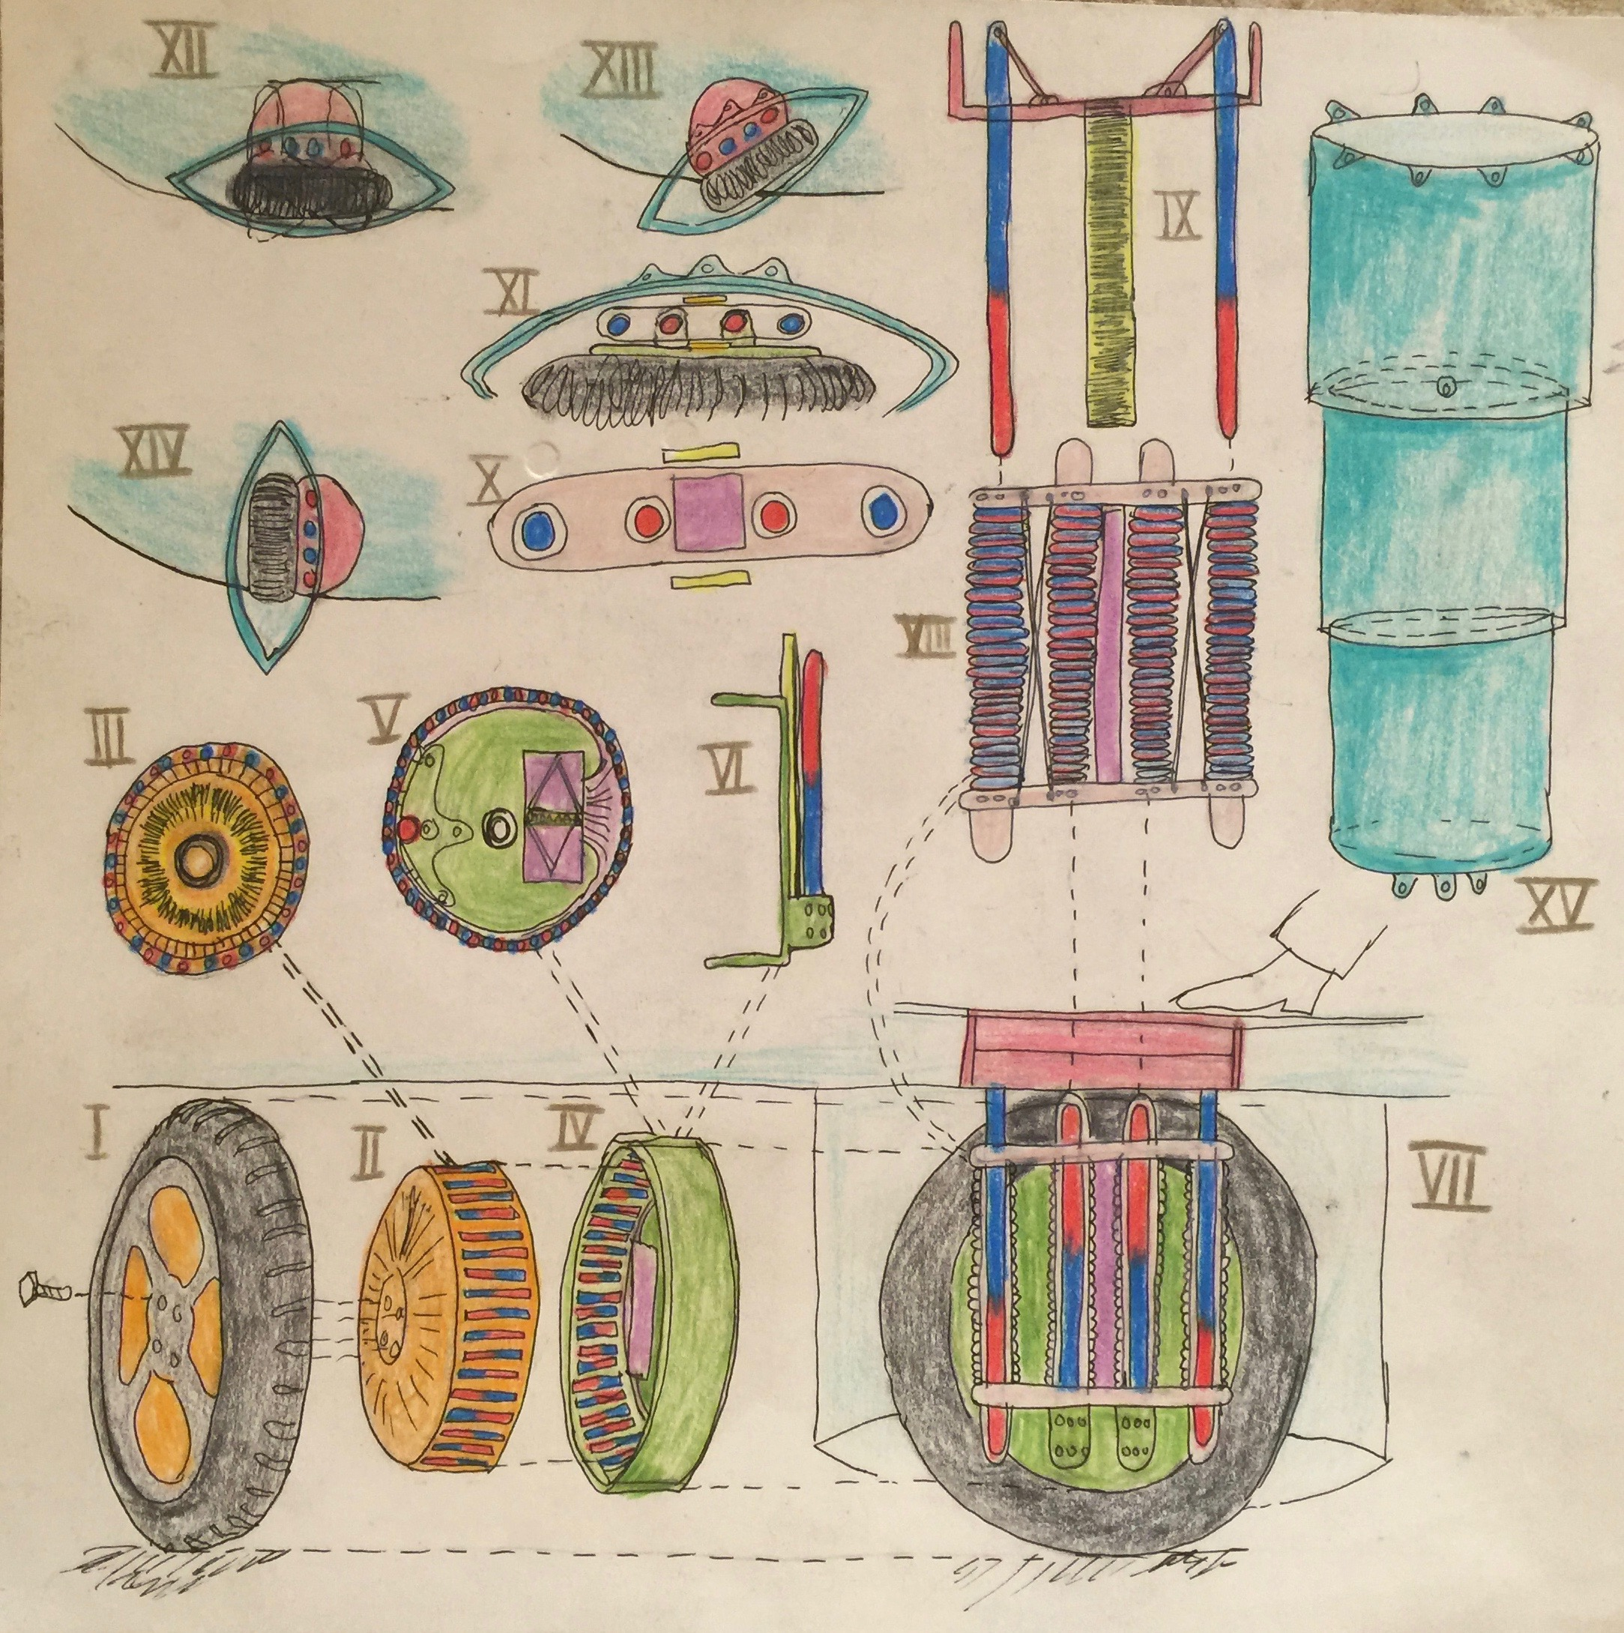Klima Ko-op

Week ending Sun 31 Jan 2016

Wheel Progress Report

# Achieved Mon 25 Jan – Sun 31 Jan 2016

# Design and Fabrication of Cutting Jig

1. I’ve designed in OpenSCAD the exact geometry (that feeds the 3D printer) to make the cutting jig. The aim is to cut six pieces of metal at 12mm x 2, 14mm x 2, 100mm and 121mm. The raw mild steel is 12x12, 10x3 and 6mm diameter.
2. Printing the main part of the jig proved to be fun and games as a) the system said it wanted 8 hours to print it and b) it printed lots of filament bed support in a strange pad that I’d not predicted and c) many print runs failed. (bolded are the minimumsolutions below).
3. Dave B and I have discussed options for sawing this metal at quite some length. There are several options to explore
   1. Angle grinder (which I have one of ) would keep cutting without going blunt. I bought two new thin blades for it. I studied YouTube videos for getting the retaining nut off that holds the blade on.
   2. I’ve looked into renting a suitable metal chop saw.
   3. There may be a simpler way to mock up the jig for the jigsaw using G clamps and bits of wood.
   4. David has offered to saw and screw together a jig for the jig saw, but fears it’ll go blunt too quickly.

# Design and Fabrication of Main Wheel Hub

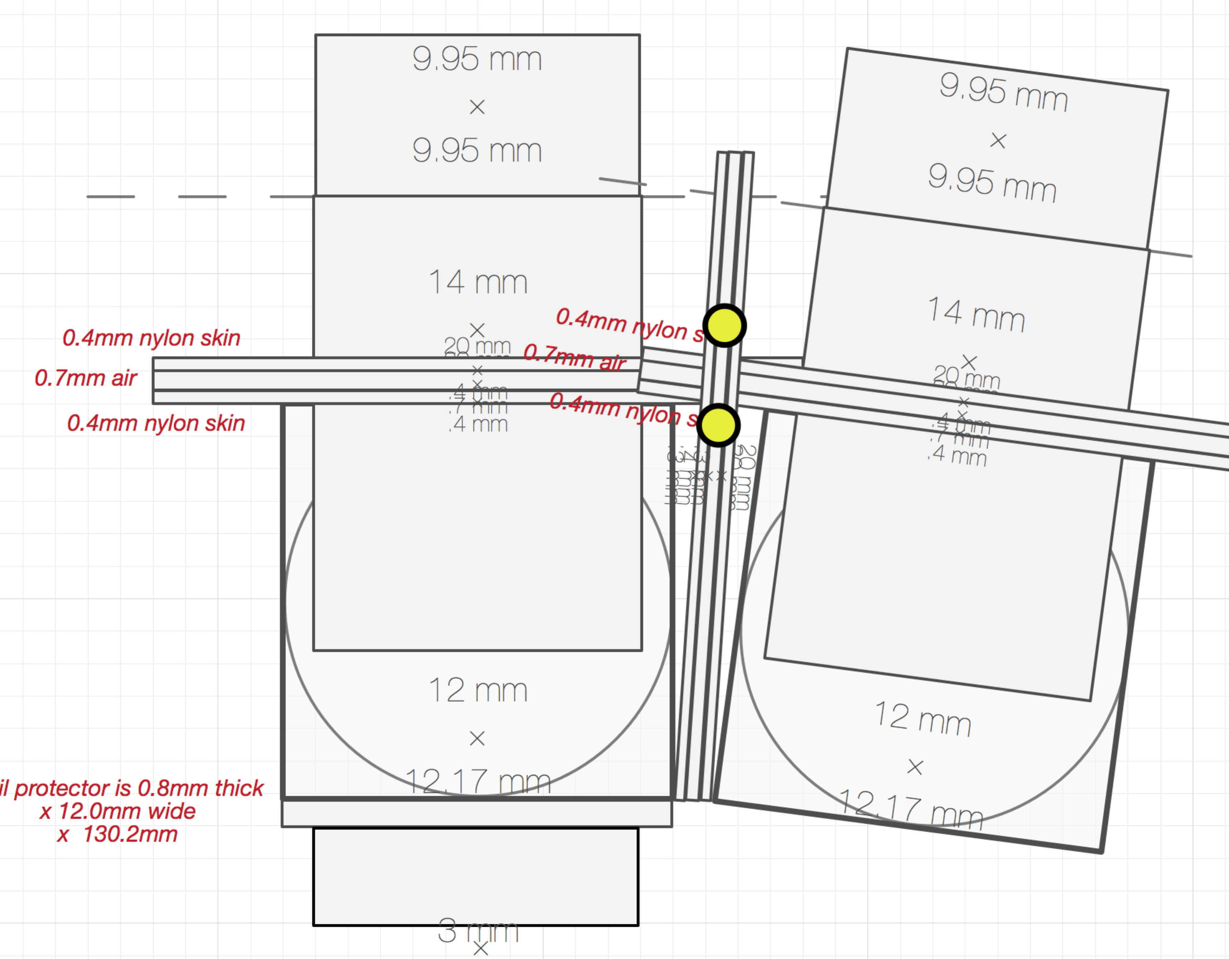

1. I’ve spent much time carefully laying out the exact geometry for the magnetic circuit to the nearest 0.1mm.
   1. I started with the above exactly to scale redraw based on exact measurements of the metal I’ve purchased (and had delivered).
   2. I’ve learned the language of an extension to OpenSCAD called the General Library of Relativity … its brilliant, allows components to be laid out relative to each other, rather than in absolute terms relative to the origin.
   3. A metal part inserted into a plastic hole needs an allowance of 0.3mm (shared into 0.15mm on each side) so that it can slide in – and let the air out. These are all designed in. There are some places where metal touches metal or where parts are held in by covers where the 0.3mm clearance is not needed. All designed in.
2. I’ve designed two covers to hold the magnetic circuit parts firmly into their places.
3. It may be necessary to design springs to hold parts in place taking into account variations due to cutting tolerances. This can be in Mark II.

# Printer – Making it more reliable

* **I changed the bolt the spool is resting on to one that is smoother.**
* I did many prints (print attempts) that tended to stop feeding filament after very roughly half an hour. Or the upper layers
* I need to
  + **Where I’ve washed off or scraped of the surface that makes the print bed sticky the filament is not securing properly to the print bed. Clean off and reapply and dry.**
  + Ensure that the knurled wheel that feeds the filament is properly lined up and engaged
  + Get delivered and installed the ball bearing races for the feed
  + **Level the print bed**
    - Get automatic print bed levelling to work – appears to need Z end stop moving from the top to the bottom. Try first with the bottom Z end stop, with setting of add 1mm (as per video) to see if that can be made to work.
  + Order new knurled wheel for feeding filament
* Complete installation of the following
  + Front LCD control panel, allowing prints to be run from SD card
  + Print the chains for tidying the X and Z cables
  + Move the Rambo control board to the left and rear to better support cable tidy up.
  + Tidy up the cables putting them in the printed chains.
  + Put the covers on the printer sides
  + Install the lights that glow behind the logos
  + Install the LCD lights that illuminate work in progress
  + When the first print head is running smoothly get